World Conference Against A & H Bombs. Hiroshima, Nagasaki,
August 2-9, 2019
VICTIMS OF MILITARY AND CIVIL NUCLEAR TECHNOLOGIES
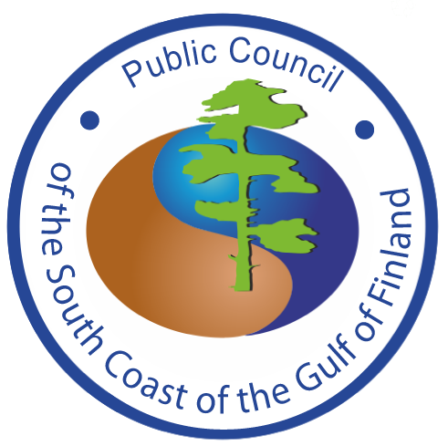
Oleg Bodrov,
Physicist, ecologist,

Chairman of the Public Council of the South Coast of the Gulf of Finland –
Interregional environmental movement of St. Petersburg and Leningrad Oblast, Russia
mob. +7 921 74 52 631, e-mail: bodrov@greenworld.org.ru
www.greenworld.org.ru www.decommission.ru www.decom-atom.org
Kon’nichiwa!
Dear participants of the conference!
74 years have passed since the atomic bombings of Hiroshima and Nagasaki. Hundreds of thousands of victims… It marked the start of an international sprint race of political leaders from different countries to obtain this tool of political blackmail.
The United States, Russia, Britain, France and China spent approximately $10 trillion dollars to develop national nuclear programs. This is comparable to the annual budget of the rest of the world for several decades.
Politicians claimed that creating and testing nuclear weapons is necessary to protect the citizens of the country. But it was precisely those citizens whom the politicians were going to defend in their own country who actually became victims of the development and testing of nuclear weapons! Moreover, the number of these victims in the country became comparable to the number of victims of nuclear bombings in Hiroshima and Nagasaki.
This was also the case in Russia. Plutonium for the first bomb was produced in Russia in the mid-1940s in the production center Mayak in the secret nuclear town of Chelyabinsk-40 in the Urals region.
These works were carried out in conditions of utmost secrecy, with neglect of health and human lives. Liquid radioactive waste was discharged into the Techa River. But this was kept secret from the locals who lived on the banks of the river.
These citizens of Russia, their pets, drank radioactive water from the river, swam and fished in it. They did it the way their ancestors did living for many centuries on the banks of this river. They were not aware of the deadly danger. These were the first victims of the Soviet plutonium bomb, similar to the one that was blown up in Nagasaki!
Dozens of accidents took place at the secret plant followed by emissions into the atmosphere and discharges of radioactive substances into the river. Information about the accidents was also a state secret.
The largest accident happened on September 29, 1957 when the tanks for storage of liquid high-level waste exploded at the plutonium production plant Mayak. 20 million Curies of radioactivity were thrown into the atmosphere. As a result, more than 20 thousand square kilometers were contaminated. Soldiers and even schoolchildren participated in the cleanup of pollution after the accident. Safety standards were not observed. Many of them received lethal doses of radiation.
After the accident some 250 settlements were relocated. The total number of officially registered affected civilians is more than 500,000 people, not including the military-liquidators of the catastrophe.
The plutonium bomb, which was just created to protect Russian citizens, killed thousands of Russian citizens in the Ural region of Russia.
After the invention of the bomb, there were numerous tests of nuclear weapons. One of them - involving 45,000 soldiers and 10,000 local residents - took place on September 14, 1954. A plane dropped a 40-kiloton nuclear bomb on the Russian territory. Many people became victims of these tests. Moreover, health problems continued into the next generation of victims of these tests.
For the production and improvement of nuclear weapons a special infrastructure was created in Russia including 10 secret nuclear cities. Later, in order to justify the enormous costs of military nuclear programs, another 10 “civilian nuclear cities” with nuclear power plants were built.
Thus, about 1.5 million people live in 20 nuclear mono-industry cities, which makes 1 % of the population of Russia. These people seek to maintain their status and the privileges of the national elite.
After the end of the cold war, they turned into the nuclear infrastructure lobby for the export of nuclear technologies. It looks like a good alternative to military confrontation, as a positive process of technological cooperation.
But it is not!
Russian VVER-1200 reactor NPPs that are being built or planned to be built in Finland and other European, Asian, African countries plan to use a fresh nuclear fuel obtained from uranium after reprocessing spent nuclear fuel from Russian nuclear submarines and nuclear power plants (NPPs).
Thus, consumers of electricity from these Russian design nuclear power plants outside of Russia will invest… in the Russian military programs. Аnd these people have no information about these hidden investments
In addition, the reprocessing of spent nuclear fuel produces liquid radioactive waste. This liquid radioactive waste (up to 2,000,000 m³/year) is discharged into natural aquatic ecosystems and migrates with rivers to the Arctic Ocean and then to northern Europe. So, the next generations of the inhabitants of the North of Europe will receive radionuclides in the form of fish and seafood on their tables. These are potential new victims in countries that do not have nuclear weapons.
Dear participants of the conference, dear colleagues. There can be no separation of nuclear technology into "dangerous military" and "secure peaceful" spheres.
I was part of the research mission that visited the radioactive contamination zone just after the Chernobyl accident. This is a tragedy comparable to Hiroshima, Nagasaki and Fukushima.
There are hundreds of thousands of victims of these technologies in Japan and in Russia. There should be no new victims!
We must stay together advocating our peaceful future without nuclear weapons and without nuclear power plants!
Arigato!

