Prescribed Burning Watch facebook group &
Stop the Harmful Forms of Prescribed Burning! public campaign

position

14.06.2019

Prescribed Burning Watch (PBW) – is an international community of independent observers of the consequences of prescribed burning practice.

Stop the Harmful Forms of Prescribed Burning! – is a public campaign which was started in the framework of PBW in June 2019.

Contents:
I. Invitation to the group……………………………………………............................................. | 2
II. The objectives of the group ………………………………………........................................... | 2
III. About the prescribed burning problem. The position of the “Stop the Harmful Forms of Prescribed Burning!” public campaign ………………………….................................................. | 4
IV. The position of scientific and technical experts of prescribed burning practice in the context of the considered problems…………………………...................................................................... | 6
V. Objectives and Tasks of the Public Campaign “Stop the Harmful Forms of Prescribed Burning!” ………………………….............................................................................................. | 10
5.1 The objectives of the public campaign “Stop the harmful forms of prescribed burning!”…... | 10
5.2 Tasks of the public campaign “Stop the harmful forms of prescribed burning!”……………. | 12
Reference…………………………................................................................................................. | 15
Appendix…………………………................................................................................................. | 17
Other definitions of “Ecocide” …………………………............................................................... | 17
Photographs illustrating the prescribed burning practice………………….................................... | 18

I. Invitation to the group
We invite to the facebook group “Prescribed Burning Watch” both - the opponents of the prescribed burning practice and the apologists (scientists, technical experts) of this practice in understanding the objectives of the group and implementation of its rules: https://www.facebook.com/groups/333909630609223/

This practice is called in different languages:

- prescribed burn, prescribed burning, controlled burn (English)
- fogo queimado, fogo prescrito, queimada controlada, queimada prescrita (Portugues)
- quemadura controlada (Spanish)
- предписанные выжигания, контролируемые палы, палы травы, палы (Russian)

II. The objectives of the group
The objectives of the group

This group is the first Internet resource representing the work of the public campaign “Stop the Harmful Forms of Prescribed Burning!”.The main purpose of the group is to develop the work of this campaign.
This goal includes:

1. Identification, formulation and discussion of the problems of wild natural ecosystems, biological diversity, climate, environment, frequency and intensity of wildfires, human health and economy, arising in different countries and different natural zone due to vast frequent implementation of the harmful forms of prescribed burning. Development of possible solutions of these problems.

The harmful forms of prescribed burnings according to the position of the campaign are the burnings implemented within natural areas (forests, steppe, savannah or any other) with a frequency that exceeds the natural frequency of wildfires in the area (that is, the period of time between wildfires that would occur in nature without human influence). We define this form of burning as a phenomenon of massive intentional multiyear ECOCIDE (see details on pages 4-5).

For such burning is typical the following: (i) implementation on huge natural areas (the burning covers up to 80-100% of all natural lands of the region during several years and up to dozens of square kilometers at a single session of burning); (ii) a long period of burning (about 50-100 years of modern prescribed burning and hundreds years of burning of ancient native people); (iii) the frequency of burning is much higher than the natural frequency of wildfires in a region. For example, the prescribed burning in many regions of the USA, Canada and Australia are implemented every 1-2 years, while the natural frequency of wildfires can be dozens and hundreds of years.

The range of all parameters of burning is wide around the world, as well as the exact information about their values is not possible to collect because of absence of the open access database of the burned lands.

2. Development of understanding what forms of prescribed burning practice can be developed in future, and what forms are drastically harmful and have to be stopped. That is, to select from the entire spectrum of prescribed burns theirs positive forms, which can probably be developed further.
3. Gathering of information about the negative consequence of prescribed burning implementation (listed in this text and all others): scientific publications, materials in press and Internet resources.
4. Gathering of information about the positive and acceptable (compromise) types of prescribed burns.
5. Gathering of information about the problems recognized inside the community of practitioners of prescribed burning and associated science. That is, what problems the scientific and technical experts of prescribed burning see inside this practice and discuss in their community?
6. Gathering of information about the intentional programs of distribution of the prescribed burning practice among the world, including those ones which use the PR (Public Relations) techniques of influence on people in order to widely promote this practice and avoid scientific evidence of its usefulness and safety.
7. Detection and discussion the complicated issues of prescribed burning practice which is difficult to formulate, like the following:
- The burning of dry grass and crop residues for agricultural purpose. Is it possible to avoid the burning in agriculture and what methods can replace the burning?
- The burning in herbaceous biomes (steppe, savannah). The issue is very controversial in Russia and other countries.
8. Gathering of summary information of prescribed burns geography, scale, frequency and consequences of any country (georeferenced databases of prescribed burns, statistics of transition of prescribed burns to wildfires, etc.).
9. Gathering of information about countries where all forms of prescribed burning are prohibited by law. Gathering of information about organizations, communities and individuals who oppose prescribed burning (to find companions).
10. Publication of news of the “Stop the Harmful Forms of Prescribed Burning!” campaign and similar activities in the world.

The material published in the group can be later used in other web resources of the campaign.

It is not encouraged in this group: to spread the regular news about the prescribed burning practice (for example, who and where did the prescribed burning, news about the training courses of prescribed burning, etc.). You can approve this practice, work in it, but this group is not a platform for its propaganda and news coverage.
First of all, it is a working platform for searching for solutions of the serious problems which this practice has already caused (the main of which is significant and possibly irreparable damage caused to natural ecosystems and biodiversity on vast territories); developing a new attitude towards this practice (see all objectives in the “Objectives and Tasks of the Public Campaign”).
The posted material should meet the tasks of the group. It should be associated with the identification, formulation and discussion of the problems of the prescribed burnings practice. Please check whether the news or other material you are posting here has this context.

III. About the prescribed burning problem. The position of the “Stop the Harmful Forms of Prescribed Burning!” public campaign.
The main focus of the campaign and the group is concentration on the significant negative consequences of the harmful forms of prescribed burning on the natural ecosystems, biological diversity, soils and natural water quality, climate, frequency and intensity of wildfires, human health and economy, which can be definitely assumed basing on the following character of their implementation:

1. Prescribed burns are often implemented on huge areas within natural lands (not only on their boundaries). Among other places, the vast frequent prescribed burning is carried out inside the protected natural territories - National parks, Wilderness Areas in USA and other types of valuable natural lands where all human influence should be limited or forbidden.

For example, according to Price et al, 2012, in seven counties of California (USA), 75.3% of the land was burned in 29 years (1979 - 2007), i.e. approximately 2% of the land of each county was burned each year. Dozens of square kilometres are burned at each session of burning (lasting from one to several days) inside the national parks of the state of Florida. That is, only in Florida it can be hundreds of square kilometres of burned natural areas annually.
According to Chris Thomson (Alternative burn theory, 2019) in Australia hundreds of square kilometres are burned during at each session. Such massive burning is implemented by helicopters, devices for ignition from the side of a moving car.

2. The most of prescribed burns are implemented very often, much more often than the natural frequency of wildfires in the area, that is, the period of time between wildfires which would occur without human influence.
For example, it is known that in the United States, Canada, Australia the frequency of prescribed burns can be 1-2 years, while the natural frequency of wildfires in different regions of the planet can be dozens, hundreds and thousands of years.

The negative consequences, which can be definitely assumed from this character of prescribed burning, include the following (the list may be incomplete):

(i) From Ecocide on burnt natural areas to loss of theirs biodiversity, destruction of functioning and degradation of their ecosystems
The harmful forms of prescribed burning, i.e. the regular prescribed burning implemented on a vast natural area with a frequency which exceeds the natural frequency of wildfires in this area or the period of time between wildfires that would occur in nature without human influence – can be called a phenomenon of massive intentional multiyear ECOCIDE.

This type of prescribed burning can be defined as Ecocide, because through frequent artificial burning occurs the destruction of the habitat of a huge variety of organisms living in grass cover, plant litter and topsoil of natural territories or those important layers of ecosystems which are called as “fuel” or “fuel load” by practitioners of prescribed burnings and which are quasi totally burned during prescribed burn operations. The burning leads to killing of organisms living in those levels of ecosystems themselves, for which it is impossible to escape from a large burned area. These are small and middle vertebrates (reptiles, amphibians, mammals, birds), invertebrates (insects, arachnids, molluscs, worms, etc.), plants, fungi and bacteria. In particular, it can be definitely assumed that this type of prescribed burning destroy or significantly reduce a key part of any natural ecosystem - a complicated community of detritophages, the organisms which under normal conditions engaged in decomposition of plant litter and other dead organic matter in natural ecosystem. This in turn should lead to violation of the possibility or reduction of speed of natural decomposition of plant litter and other organic material in regularly burned natural territory. The direct result of the latter consequence should be a “vicious circle”: the more people burn, the more plant litter (which is entitled by the practitioners of prescribed burns as “fuel”) accumulates in ecosystems, forcing people to burn even more.
Thus, the direct result of this type of prescribed burning should be the destruction of normal functioning of the entire natural ecosystem. The strong negative impact of which can be assumed at all levels of the ecosystem. The direct obvious consequences of this are degradation of this ecosystem (removal from the natural state) and loss of its biodiversity. It can also be supposed that the multiyear frequent artificial burning has led to complete disappearance of many species of organisms from the regularly burned layers of ecosystems (grass cover, plant litter and topsoil) i.e. to the loss of biodiversity on the planet. This risk is especially high for tropical and subtropical regions which are home for many endemic species with a small natural habitat.
By analogy with the definition of the notion "Genocide", Ecocide can be defined as a form of collective action committed with the intention to completely or partially destroy any biological species of organisms or habitat for species of organisms. The United Nations has been recognized genocide as an international crime since 1948. What happens as a result of vast frequent prescribed burning of grass cover, plant litter and topsoil in natural lands is fully consistent with this definition of ecocide. Other definitions of Ecocide, which also correspond to such types of prescribed burns, are given in the Appendix (at the bottom of the document).

One of the key justifications for the statement that this form of prescribed burns is Ecocide is the interval between artificial burns. The fact that the interval between prescribed burning is considerably higher than the natural interval between wildfires, gives a reason to determine this form of prescribed burns as Ecocide.

Without human influence the wildfires in nature can be caused almost only by dry thunderstorms (a lightning without rain) - a rather rare meteorological event. The natural frequency of wildfires can be tens, hundreds or thousands of years. Prescribed burning is carried out in many places in the United States, Australia, Canada, Portugal and other countries every 1-2 years.

(ii) Other very probable negative consequences of the frequent artificial burning of grass cover, plant litter and topsoil:
- Carbon dioxide emissions into the atmosphere and exacerbation the problem of global climate change. Without artificial burning a plant litter is decomposed by detritophages and turns into soil.
- Prescribed burning, like wildfires, produces huge amounts of soot (micro particles of carbon). The transfer of air mass saturated with soot to the Arctic and Antarctic regions and deposition of soot on glaciers, as well as its deposition on mountain glaciers, causes a decrease of albedo of glaciers and their melting. This effect exacerbates the global and local climatic changes, has a negative impact on the condition of glacier and near-glacier ecosystems. This phenomenon was studied and described for wildfires. For prescribed burning can be assumed the same effect.
- Soil depletion and violation of the process of soils normal formation (due to burning and removal of plant litter), increase of erosion of slopes.
- Deterioration of people’s health due to heavy smoke caused by prescribed burning. Children, pregnant women and people with heart and lung diseases can especially suffer.
- The prescribed burning carried out in large areas can kill also large wild animals which can’t hide from the fire. In addition, press analysis shows that people also can die from such prescribed burns. A recent example of such an accident that could have occurred as a result of prescribed burning in the forests of Fort Jackson is described in the article at the link. According to the expert's brief comment – “Prescribed fires are supposed to be carefully managed, and although there is risk, it is rare for anyone to die in such fires, according to the S.C. Forestry Commission” - such cases happen in the United States.
(iii) Direct and indirect effects of prescribed burns on the increase of wildfires

- The massive use of prescribed burning and their wide propaganda in the society can have direct and indirect influence on the growth of frequency and intensity of wildfires (that is, to work in the opposite way of their main purpose, not to reduce, but to increase the number of wildfires). These very likely consequences are the follows:

- The prescribed burns sometimes get out of control and cause wildfires themselves. Such cases are reported by the press. It is not possible (or very difficult) for an independent observer to estimate the frequency of such cases throughout the country, due to the lack of open access database of prescribed burns and an open clear statistics of such incidents. Perhaps such a database and statistics exist, but we have not seen them yet for any country.
An example of a big forest fire caused by prescribed burning is the case of the Cerro Grande Fire in New Mexico in 2000 (wiki):

- The practice of prescribed burning is widely promoted in the societies of the countries where it is used. This is done through television, press, social networks (Facebook groups), training courses and the special governmental programs of influence on the population. The well-paid state programs of prescribed burning propaganda probably have the greatest impact on the population and, for this reason, they are the most dangerous. Examples of those programs in the United States are illustrated by the following papers: Butler and Goldstein, 2010; McCaffrey, 2006)

The intensive propaganda of prescribed burning teaches ordinary people (including children) to careless attitude to fire in natural territories and practice of burning for any reason. It teaches from a young age. There are examples of promoting and teaching of prescribe burning practices among school children, for example, Maclay School, 2019. It can be definitely assumed the result of this propaganda – the growing number of people who will burn for security and fun reason on private and public lands without proper control, professional skills and official permits. It can be definitely assumed that these factors can significantly increase the frequency of severe wildfires. At the same time, they are difficult to detect and prevent, because in many countries the control of any people's activity on private lands is limited or not possible. In other words, the wildfires launched by burning of ordinary not skilled people (including children) on private and public lands are almost impossible to prevent as well as it should be very hard to detect this reason as a reason of wildfires.
The photographs with examples of prescribed burns in Appendix (at the bottom of the document) illustrate the considered negative consequences of this practice.

IV. The position of scientific and technical experts of prescribed burning practice in the context of the considered problems
The feedback of scientific and technical experts of prescribed burning practice about the obvious (very probable) negative consequences of prescribed burning usage and propaganda
The considered obvious (very probable) negative consequences of prescribed burning practice are recognized in society but only a little discussed. In general, they are almost completely ignored by the scientific and technical experts of this practice. This conclusion we obtained through a long personal communications with those experts in the facebook groups consolidating the apologists of prescribed burning practice (Association of Fire Management Activists and several others, look Reference list).

Through the personal conversation in these groups we created impression that members of those communities sincerely believe in complete security and the importance of prescribed burning practice. They did never think about the negative obvious consequences of this practice, considered in the position of the campaign. It allows to conclude that they haven't read about this topic anywhere, this theme is not covered at all by information sources in the countries where the prescribed burning is intensively used.
The personal discussions in the groups also did not help to convince them, their mind seems to be closed to such understanding. They ignore unpleasant questions and arguments (do not answer, change the topic, use demagoguery techniques in order to get away from a direct answer).

In general, we see that the whole society in the world does not pay appropriate attention to these hard problems, i.e. the widespread usage of harmful forms of prescribed burning in many countries; the existence of a list of very serious (catastrophic!) negative consequences of this practice, the lack of scientific study and discussion of these possible consequences, the presence of a wide propaganda of this practice and its unlimited distribution among the world.

In those countries where the prescribed burning is prohibited by law or not used (Israel, Cyprus, Latvia, Finland, partly Russia) the press do not write about these problems and covers only their regional specifics (remind the population about the prohibition of burning, remind that grass burning can lead wildfires). In those countries where the harmful forms of prescribed burning is intensively used (USA, Canada, several European countries, several African counters, Australia, Argentina), this practice is covered only from a positive side. When press and scientists write about any disadvantages or questions of prescribed burning, they present them as an insignificant, unimportant factor.

This can be explained by the fact that the authorities, the press, the science, the environmental organizations and ordinary people do not have a true awareness about the spectrum of serious negative consequences of prescribed burning. The statements of unconditional benefit and safety of this practice are dominated on the surface of the information coverage. Probably it is the result of well paid propaganda campaigns promoting the prescribed burning industry among the world. The facebook groups mentioned above – are a clear example of wide propaganda of prescribed burning which is provided by the apologists of this practice among the countries.

There are quasi no scientific investigations devoted to study of the considered obvious negative effects of the vast frequent prescribed burning. The most of researchers focused their studies on the benefits which burning gives to one or a few plant or animal species in ecosystem, which usually called as “fire-adapted species”. The presence of some of these species in natural area is considered by scientific experts as indicator and evidence that the entire natural area is “fire-adapted ecosystem” and, for this reason, it needs in artificial burning, which are usually implemented with frequency much more higher than the natural frequency between wildfires in this area. The influence of frequent artificial burning on all other species of ecosystem and on other components of biosphere are usually totally ignored. An example of this scientific relationship is seen in the Gabbert, 2019:
“On average, over the past five years, 11,819 acres have been burned on post annually, along with 2,388 thinned. “It creates a habitat (RCWs-- red-cockaded woodpecker) prefer,” said wildlife biologist. It allows for open park lighting”

Another example of this attitude is given in Fig. 4 (Appendix). There are a lot of similar examples of prescribed burns implementation for the benefits of a single or a few species in ecosystem with total ignorance of the condition of all other species in this ecosystem. They are presented in scientific papers and press. Consideration the ecosystems of many regions of the planet as “fire-adapted ecosystem” which are needed in frequent artificial burning is one of the main postulates of the prescribed burning paradigm. We believe that it is false postulate, because it contradicts to Ecology science.
About the frequency of prescribed burning and the natural intervals between wildfires
It should be noted that in 50 or more years of the development of the prescribed burning practice, its apologists have not initiated any research devoted to study the natural frequency of wildfires in any region of the planet. At least we are not aware of such studies. This means that scientific and technical experts of prescribed burning practice do not have the information about the natural intervals between wildfires for none of regions of the planet.
From this it can be concluded the natural frequency of wildfires is not even supposed to take into account in prescribed burning operations. Apologists of this practice are characterized by misunderstanding or ignoring these questions in the dialogues. However, some of them assert that they consider this interval in the prescribed burning, which can’t be truth, because the information of natural interval between wildfires does not exist for none of the region of the planet.

The studies of frequency of wildfires about 300-400 years ago were conducted in the United States for a few regions. This method uses the old trees which save the traces of wildfires in their wood. But this is a period of time when the territory of North America was inhabited by American Indians or by European colonists, who themselves intensively burned. Therefore, these studies provide data about the frequency of anthropogenic burning, not natural wildfires. However the practitioners of prescribed burning do not consider even these frequency and burn more often, than American Indians did.

As can be concluded from the literature analysis and communication with prescribed burning practitioners, the intervals between burnings are determined either from the well-being of one or a few species of ecosystem which are called as “fire-adapted” (often they are economic tree species or some animal species who are restored by this way). Or most often only by the "fuel load" parameter in the ecosystem, that is, without any environmental parameters at all (Fig. 4, Appendix).

Does the prescribed burning really help reduce wildfires?
In addition to the considered problems, the issue of effectiveness of reduction the “fuel load” (which is mostly a plant litter and grass cover) by regularly burning as a measure to mitigate or prevent wildfires are vigorously debated.

Thus, the United States Geological Survey (USGS) conducted a study using its own georeferenced data of the territories passed by wildfires and prescribed burning for 29 years (1979-2007) in seven counties of the state of California (USA). This study revealed that prescribed burning showed 0% efficacy in prevention of subsequent wildfires. The result of the study also doubt on the argument that the accumulation of fuel due to the suppression of past fires increased the probability of large wildfires. These data were published in the paper Price et al, 2012. In addition, the authors suggested that worldwide the effectiveness of the prescribed burning for mitigation of wildfires can be very low. They concluded that it is necessary to burn from 1 to 4 hectares of the territory in order to prevent a subsequent wildfire on 1 hectare of this territory. For this reason, it makes sense to carry out the prescribed burning only for the local protection of valuable objects (human settlements, valuable natural areas) and to conduct them in narrow bands:
“The result also casts further doubt on the argument that fuel accumulation due to past fire suppression has increased the chances of large, damaging fires occurring.
Our study suggests that low encounter rates and relatively rapid fuel recovery means that fire activity is relatively insensitive to the distribution of fuel ages and so the effect of suppression is likely to be minimal.
Our study has found that regional-scale patterns of fire extent in southern coastal California are not influenced by fuel age, and hence prescribed fire treatment will not help to reduce wildfire area. However, this does not negate the inhibitory effect that individual burned patches have on subsequent fire, should one encounter a recently burned patch. Hence, fuel treatment should be focussed close to the assets that need protection”. (Price et al, 2012)

The data from Australian scientist Philip Zylstra show that flammability (i.e. the number and intensity of wildfires) correlates much more with the composition and structure of plants than with the fuel load in ecosystems. He found that plant successions of different natural zones formed after prescribed burning much more easily covered by wildfire than the mature ecosystems, i.e. those ones which do not have burning or wildfire for many years. (Zylstra P. 2011, 2013, 2016, 2018)

Conclusion
In general, the whole paradigm of prescribed burning is based on the idea that it is necessary to constantly burn out the “fuel load” (that is, regularly almost completely destroy or severely deform the key parts of ecosystems – grass cover, plant litter and topsoil) in order to prevent or mitigate the subsequent wildfires.

In other words, for the purpose of reduction the wildfire, with approval of science and the governments the massive multiyear Ecocide is implemented and causes the destruction of the functionality of ecosystems and loss of biodiversity, the killing of a huge number of living organisms.

The ecocide from massive frequent prescribed burning has been happening for many years and on a huge scale. For example, in some states of the United States, provinces of Australia and Canada – the most of natural territories, including lands of national parks and even a number of wilderness areas of USA (the most valuable wild nature areas protected by law from any human impacts), are exposed to frequent prescribed burning about 50 or more years. The exact data of the scale and geography of the natural areas suffered from prescribed burning should be found out. In the same countries the modern burning was preceded by centuries of burning of ancient native people (American indigenous, Australian aborigine).
The scale of burning of ancient people is not well known. According to scientists, the burning of native ancient people in North and South America, Australia, Africa – significantly changed the natural ecosystems. Probably the ancient burning caused the disappearance of many species of flora and fauna.

Undoubtedly, that the strong wildfires is a disaster for nature and people. But it is not possible to treat one disaster by another disaster, which is many times worse! This is what is happening now when the prescribed burning is used for reduction of wildfires.

At the same time, even the main basis of the prescribed burning paradigm – the effectiveness of burning for mitigation of wildfires is doubtful! The independent research suggests zero or very low efficiency of prescribed burning for mitigation of wildfires (Price et al, 2012, Zylstra P. 2011, 2013, 2016, 2018). If we add to this the obvious indirect effect of prescribed burns on wildfires (the burning themselves often start wildfires; the propaganda of burning in society motivate the ordinary people to burn, which further increases probability of wildfires), the benefits of prescribed burns turn exactly the opposite. Most likely, they do not reduce wildfires, but increase them. This hypothesis can be confirmed or disproved when an open database of prescribed burns will be created in the countries (see “The first task of the campaign” on page 12).

V. Objectives and Tasks of the Public Campaign “Stop the Harmful Forms of Prescribed Burning!”
This facebook group represents the public campaign “Stop the harmful forms of prescribed burning!” which has the following objectives:

5.1 The objectives of the public campaign “Stop the harmful forms of prescribed burning!”
First objective of the campaign
To launch implementation of independent scientific studies and public control of prescribed burning scale (geography, area, frequency) and negative consequences for biodiversity and functioning of natural ecosystems, condition of soils, natural waters, climate and health of people. To study the direct and indirect impact of the massive practice and wide propaganda of prescribed burning on the frequency of severe wildfires, and through this their impact on welfare of people and economy.
It is necessary to launch such independent investigations, public control and publications of the results in each country where this practice is used, that is, in the USA, Canada, Australia, Argentina, South Africa, some other countries of Africa, Portugal, Spain, Italy, some other countries of Europe, Russia and not mentioned in the list.
Second objective of the campaign
To implement the following purposes set for this group and considered in the position in the scale of the global community and, above all, in the countries conducting the harmful forms of prescribed burning, which we define as the burning implemented inside the vast natural lands with a frequency that exceeds the natural frequency of wildfires in this area (that is the period of time between wildfires that would occur in nature without human influence):

Purpose 1. The problems caused by regularly frequent prescribed burning on the vast natural areas (i.e. the negative consequences of harmful forms of prescribed burns which can be definitely assumed basing on the character of their implementation) should be formulated, recognized, studied and discussed:
- The problem of loss of biodiversity, the destruction of functionality of natural ecosystems, degradation of natural ecosystems (due to frequent destruction of the habitat of a huge variety of organisms living in grass cover, plant litter and topsoil of natural territories and killing of those organisms themselves; the violation by this of the possibility or reduction of speed of natural decomposition of plant litter in ecosystem);
- The problem of damage on soil conditions (due to soil depletion and disruption of the process of their normal formation due to the burning of plant litter); and natural waters (due to pollution by products of burning).
- The problem of influence on climate: both on global climate (due to the burning of plant organic matter and emission of large volume of carbon dioxide in the atmosphere, which without burning would turn into the soils without carbon dioxide emission) and on local climate especially of glacier and near-glacier ecosystems (due to deposition of soot on glaciers and their melting).
- The problem of influence of prescribed burning on the human’s health (due to strong smoking and incidents inside the burned areas).
- The problems of direct and indirect influence of massive prescribed burning practice and its wide propaganda in society on the frequency of severe wildfires, and through this - on people’s welfare and economy of the country (prescribed burns sometimes start wildfires themselves and motivate the ordinary people to burn, which further increases the probability of wildfires).

Purpose 2. Development of possible solutions to these problems.
Purpose 3. Launch of solution of these problems.
Purpose 4. Determine, what types of prescribed burns can be carried out in the future.

Third objective of the campaign
The campaign is aimed at termination the harmful or destructive forms of prescribed burning (as well as illegal burning of the same character), which we define as the burning implemented inside natural lands with a frequency which exceed the natural frequency of wildfires in this area or the period of time between wildfires that would occur in nature without human influence).
At the same time, we suppose that the forms of prescribed burning useful for wildfires prevention and fighting, restoration of the disturbed natural ecosystems or serve as an acceptable compromise in those purposes can exist.

The third big goal of the campaign is to highlight such positive, non-harmful forms of prescribed burning and to focus on them as an alternative to destructive forms of burning. We believe that this work should be carried out in open public space (with information coverage of press, social networks and Internet resources) and in conjunction with formulation and solution of hard problems of damage which already have been done to natural ecosystems by the harmful forms of prescribed burning.

For this purpose, the information about the alternative (positive, non-harmful and compromise) forms of prescribed burns is collected in the group.

The promising alternative forms of prescribed burns can be the following (the list may be incomplete):
- Use the prescribed burning for creation of relatively narrow stripes avoid of vegetation for making the barriers for wildfires. Do it around the human settlements, agricultural farms, valuable natural areas (i.e. around the specific valuable objects), when the danger of wildfires is great and other ways of wildfires prevention (mechanical cutting the grass, ploughing) are not acceptable.
The main difference from the harmful forms of prescribed burning – the burning is not implemented inside the natural territories, it is carried out only on theirs edge.

This type of prescribed burning can be considered as an acceptable compromise (a relatively little damage and risk to the ecosystem to save it from fires). However, if it possible, it is necessary to use other ways to create the strips avoid of plant cover (digging, cutting the grass). This type of prescribed burning must also be registered in the prescribed burning database (see “The first task of the campaign” on pages 12) to create an opportunity to detect the performers of burning which launch of wildfires.
For example in Russia exactly this type of prescribed burning is carried out to protect forests from fires. But they often are implemented carelessly (with violation of safety rules, without an appropriate control), so they often lead to the forest fires.

- Use of burning as a method of fighting against the current wildfire (when a counter fire is started by burning to stop the movement of the passing fire).

- Use the prescribed burning to restore the disturbed natural ecosystem.
For example, use the burning to restore an ecosystem damaged by invasive plant species. To implement a burning at once to transfer the entire ecosystem to the initial stage of succession, after which never to burn again, only to monitor the restoration of native vegetation. Such forms of prescribed burning for the restoration of natural forest vegetation are used in Finland (according to the personal report of the representative of the Finnish forest service).

This method may be very promising, but it should be used thoughtfully, with rigorous use of scientific methods and environmental concepts.

Thus, exactly the goals of restoration of natural ecosystems are often used to justify the implementation of frequent prescribed burning in the national parks of the USA, Canada, Europe, Australia. However, the scientists there aim to support some plant and animal species that are supposed to get benefits from burning (they call those species as “adapted to fire species”).

This issue will be discussed in the material of the campaign later (it is a big complicated topic). However, in short, the principle should be simple. The frequency of artificial burning should not be higher than the frequency of natural wildfires in the area (i.e. the interval between wildfires that would occur in nature without human influence). If scientists can prove that they implement the burning in the natural territory in accordance with this condition – then they can realize it. But now it is impossible to prove it for any region of the planet, because there is no credible scientific data on the natural frequency of wildfires (due to absence of such investigations). At the same time, currently quasi all regular prescribed burns are carried out with a frequency much higher than the natural frequency of wildfires, that is, they are harmful to ecosystems.

5.2 Tasks of the public campaign “Stop the harmful forms of prescribed burning!”
The Tasks of the campaign are relatively small specific steps that should be implemented to achieve the objective of the campaign.

The first task of the campaign: creation of an open access summary georeferenced database of lands passed by prescribed burning
To be able to fulfil the first objective of the campaign, we aim to achieve the creation of an open access summary georeferenced database of lands passed by prescribed burning for each country which use this practice (authorized and, if possible, illegal). These data should be laid out for the past existent years. In the future it is necessary to put them every year in each country, where the prescribed burns are implemented for wildfires prevention, agricultural, scientific, ecosystem restoration and all other purposes.

Each case of prescribed burning implementation should be registered by the following parameters in this database:
• georeferenced polygon of the burnt area (shape polygonal file as a standard file of GIS systems);
• date of burning (or interval of dates, for example, from 10 to 15 March 2019);
• performer of burning (company and\or a person responsible for the burning).
Currently, no single country in the world does not have an open access database of areas passed by prescribed burning. Some of these data exist in a closed form distributed to hundreds of companies which perform the burning. In many cases, burns are recorded only on paper or PDF\DOCX files in the form of textual reports. There is no summary georeferenced database of lands burnt by artificial burning that is easy to analyze. The burning carried out inside the private property most likely are not recorded anywhere at all.

Hypothetically, these data can be obtained by requesting in all these companies, paying a lot of money for data and spending a lot of time to turn different reports into a summary database. However, absence of a consolidated standard and open access (free of charge) summary database of georeferenced data of prescribed burns for each country makes it impossible to conduct independent public control and independent scientific research of prescribed burns geography, scale, frequency and consequences.

If the summary georeferenced database of lands passed by prescribed burning will be created, it will open the wide opportunities for establishment of independent public control and scientific study of the entity and consequences of prescribed burning. Also it will be extremely important for improving the methods of positive forms of this practice and for justification its safety and usefulness. Those opportunities are the following:
1. The independent researchers and environmentalists will be able to study the geography, scale, frequency, positive and negative consequences of prescribed burns over all years of published data using the analytical and mapping functions of GIS and Remote sensing techniques, as well as other open access georeferenced databases of natural and social process.
2. The possibility for any independent observer to reveal cases when prescribed burns launch wildfires will be created. Currently it is impossible for an independent observer (ordinary citizen, environmental organization, etc.) to reveal these cases. The use of open access summary georeferenced database of lands passed by prescribed burning in combination with free services that show wildfires as hotspots on the ground for every day (for example, the Fire Information for Resource Management System, FIRMS)) will allow to prove the guilt of the company or the owner of the private territory conducting the burning in the initiated wildfire. This, in turn, will allow in cases when prescribed burning was a reason of wildfires do the following things:
- To put the financial and juridical responsibility for the damage caused by wildfire to the state budget, people’s property and nature on the perpetrators of this wildfire, that is on the company or land’s owners who carried out the burning which launched the wildfire.
- To increase the responsibility of all performers of prescribed burning and to reduce their volumes (people will try to avoid unnecessary burning, because they will be afraid to start a fire and pay for the damage).
We suppose that only this simple measure (the creation of open access summary georeferenced database of lands passed by prescribed burning) in a few years may significantly reduce the number of severe wildfires in the United States, southern Europe, Australia, Russia and other countries.

The second task of the campaign: recognition the harmful forms of prescribed burning as Ecocide
The second task of the campaign is to achieve recognition of the harmful forms of prescribed burning (i.e. the burning implemented inside the natural lands with a frequency which exceed the natural frequency of wildfires in this area or the period of time between wildfires that would occur in nature without human influence) at the nationals, European Union (EU) and United Nations (UN) levels as the phenomenon of ECOCIDE.
To draw an analogy between this phenomenon of Ecocide and the phenomenon of Genocide, which was recognized as an international crime in 1948 by the United Nations General Assembly.
By analogy with the definition of the notion "Genocide", Ecocide can be defined as a form of collective action committed with the intention to completely or partially destroy any biological species of organisms or habitat for species of organisms. The United Nations has been recognizing Genocide as an international crime since 1948. What happens as a result of vast frequent prescribed burning of grass cover, plant litter and topsoil in natural lands is fully consistent with this definition of Ecocide.

The full list of reasons why the harmful form of prescribed burning can be defined as Ecocide is considered on pages 4- 5. The full definition of harmful forms of prescribed burnings according to the position of the campaign is given on page 2.

We consider it unacceptable for the doubtful purposes of wildfires mitigation and for any other purpose to allow the massive Ecocide, destruction the functionality of natural ecosystem and reduction of their biodiversity, as well as other obvious negative consequences of massive frequent prescribed burning!

Therefore, we will achieve the condemnation of this phenomenon of Ecocide at the level of the United Nations, the European Union and national levels and recognition it as international and criminal offense as it was done for the phenomenon of Genocide in 1948.

For information. Currently, Ecocide is recognized as a criminal offense only in 10 countries - Armenia, Georgia, Ukraine, Belarus, Ecuador, Kazakhstan, Kyrgyzstan, Moldova, Russia, Tajikistan, Uzbekistan and Vietnam. In 2010 and 2013, the attempts to give the concept of Ecocide the status of an international crime and a criminal offence in the European Union were made. Both attempts failed.

Continuity. If this task of the campaign will be implemented, it will fulfil of the civil initiative for the recognition of Ecocide as a criminal offense in the European Union (European Citizens' Initiative), which was submitted in 2013 to the European Union; and the project of the environmental lawyer Polly Higgins who submitted a proposal to the United Nations in 2010 about recognition of the concept of Ecocide as an international crime (Details: https://en.wikipedia.org/wiki/Ecocide)

Reference
Papers

Price, O. F, Bradstock R. A., Keeley J. E., and Syphard A. D. The impact of antecedent fire area on burned area in southern California coastal ecosystems. Journal of Environmental Management, 113, 2012, 301-307.

https://www.academia.edu/14472887/The_impact_of_antecedent_fire_area_on_burned_area_in_southern_California_coastal_ecosystems

Zylstra P. The historical influence of fire on the flammability of subalpine Snowgum forest and woodland. - Victorian Naturalist 130(6), 2013, p.232-239.
https://www.researchgate.net/publication/270395883_The_historical_influence_of_fire_on_the_flammability_of_subalpine_Snowgum_forest_and_woodland

Zylstra P. Forest Flammability Modelling and Managing a Complex System.- Thesis submitted in fulfilment of the requirements for the degree of Doctor of Philosophy at School of Physical, Environmental and Mathematical Sciences, The University of New South Wales Australian Defence Force Academy, 2011, 435 p.

https://www.researchgate.net/publication/270395888_Forest_Flammability_Modelling_and_Managing_a_Complex_System

Zylstra P., Bradstock R.A., Bedward M., Penman T.D., Doherty M.D., Weber R.0., Gill A.M., Cary G.J. Biophysical Mechanistic Modelling Quantifies the Effects of Plant Traits on Fire Severity: Species, Not Surface Fuel Loads, Determine Flame Dimensions in Eucalypt Forests.- PLOS ONE, DOI:10.1371/journal.pone.0160715, 2016. p 1-24.

https://www.researchgate.net/publication/306217579_Biophysical_Mechanistic_Modelling_Quantifies_the_Effects_of_Plant_Traits_on_Fire_Severity_Species_Not_Surface_Fuel_Loads_Determine_Flame_Dimensions_in_Eucalypt_Forests

Zylstra P. Explaining feedbacks between fire and flammability in the Snowgums and beyond. - Australasian Plant Conservation, Vol 24, №4, 2016б p. 14-16.
https://www.researchgate.net/publication/303840513_Explaining_feedbacks_between_fire_and_flammability_in_the_Snowgums_and_beyond

Zylstra P. Flammability dynamics in the Australian Alps. - Austral Ecology 43(4), 2018, p.578–591
https://www.researchgate.net/publication/323760393_Flammability_dynamics_in_the_Australian_Alps

Alternative burn theory by Chris Thomson, January 17, 2019
https://gsweekender.com.au/great-southern-prescribed-burning-alternative-burn-theory/

Philip Zylstra - research Fellow at University of Wollongong, Centre for Environmental Risk Management of Bushfires, Centre for Sustainable Ecosystem Solutions.

Press and Internet sources

Butler, W. H., and B. E. Goldstein. The US Fire Learning Network: springing a rigidity trap through multiscalar collaborative networks. - Ecology and Society, 2010, 15(3). http://www.ecologyandsociety.org/vol15/iss3/art21

Cerro Grande Fire in New Mexico in 2000, Wikipedia
https://en.m.wikipedia.org/wiki/Cerro_Grande_Fire?fbclid=IwAR39p0QxcN9rK1qoePYaAgdHE33O1ohjTxmk3X5h6XE16gAd-j6g_o2pdsE

Gabbert B. Wildlife biologist dies at prescribed fire at Fort Jackson, South Carolina. - Wildfire Today, May 23, 2019.
https://wildfiretoday.com/2019/05/23/wildlife-biologist-dies-at-prescribed-fire-at-fort-jackson-south-carolina/?fbclid=IwAR3QjwZddQuopL9VFj2i14F3b87auz6s2NfCfYbG7BsXcyiDO_OY-ZptV6I

Maclay School, Tall Timbers will conduct prescribed burn demonstration. - Tallahassee Democrat, 7 May 2019 (article in press):
https://www.tallahassee.com/story/life/2019/05/07/maclay-tall-timbers-conduct-burn-demonstration/1128671001/?fbclid=IwAR377-cg60fwZVmL68RKErCHY5hKFY-zYRbx2PVV4oHoqTAJ8ztYV3F9HFg

McCaffrey S. M. Prescribed fire: What influences public approval. - In: Dickinson, Matthew B., ed. 2006. Fire in eastern oak forests: delivering science to land managers, proceedings of a conference; 2005 November 15-17; Columbus, OH. Gen. Tech. Rep. NRS-P-1. Newtown Square, PA: U.S. Department of Agriculture, Forest Service, Northern Research Station: 192-198.
https://www.nrs.fs.fed.us/pubs/gtr/gtr_nrs-p1/mccaffrey_p1_192.pdf

Sources of personal communication (social networks)
Association of Fire Management Activists is the largest facebook group and community joined the apologists of prescribed burning practice (scientific and technical experts, practitioners, professors, representatives of burning companies and federal agencies). This group was created by Ed Komarek, a great enthusiastic of this practice. He also created the regional groups where material is repeated from the main group - Prescribed Fire Asia, Prescribed Fire Australia, Prescribed Fire North America, Prescribed Fire Central & South America, Prescribed Fire Africa
All these groups are the example of wide propaganda of prescribed burning which is provided by the apologists of this practice among the countries. Except those groups, there are a lot of other Facebook groups dedicated to the benefits of prescribed burning. The propaganda of harmful forms of prescribed burning is conducted mainly.

Appendix
Other definitions of “Ecocide”
There are several definitions of a concept “Ecocide” which can also be used to denote the massive frequent prescribed burning of grass, plant litter and topsoil as an Ecocide phenomenon.

Wikipedia (https://en.wikipedia.org/wiki/Ecocide):
Ecocide describes attempts to criminalize human activities that cause extensive damage to, destruction of or loss of ecosystems of a given territory; and which diminish the health and well-being of species within these ecosystems including humans. It involves transgressions that violate the principles of environmental justice, ecological justice and species justice. When this occurs as a result of human behaviour, advocates argue that a crime has occurred. However, this has not yet been accepted as an international crime by the United Nations.

From the book and movement of Polly Higgins "Eradicating Ecocide": https://eradicatingecocide.com/

Ecocide is the extensive damage to, destruction of or loss of ecosystem(s) of a given territory, whether by human agency or by other causes, to such an extent that peaceful enjoyment by the inhabitants of that territory has been or will be severely diminished.
Ecocide is a crime against the living natural world – ecosystem loss, damage or destruction. Ecocide is a crime against the Earth, not just humans. Further, ecocide can also be climate crime: dangerous industrial activity causes climate ecocide.

Polly Higgins is a lawyer and environmentalist who fought for the recognition of Ecocide as an international crime. She submitted a proposal to the United Nations in 2010, but it was rejected. Polly Higgins died at the age of 50 on 21 April 2019.

Photographs illustrating the prescribed burning practice

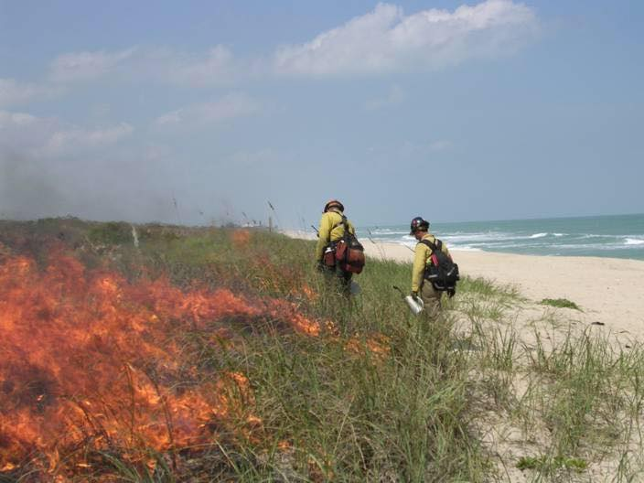
Fig 1. Prescribed burns in the national park of the Florida state, USA. Technicians burn dunes near the ocean.
Even the scientific experts of prescribed burning practice criticised these actions as unwise measures. The dunes have been recovering for decades after the fire. What is the reason of burning the dunes inside the national park (protected natural area)? How many years they will recover after this fire? To these questions we failed to answer in the group “South Florida Interagency Fire Management Council” (where this photo was put on the background), and in the group “Association of Fire Management Activists” (where this photo was shared). But the comments of two practitioners of prescribed burning under this photo are very typical. They like it. They do not know the answer to the above questions, they do not need it. The most important – that the fire is burning well!
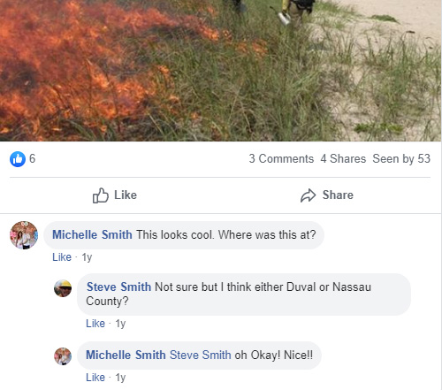

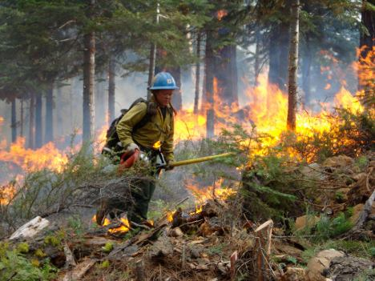
Fig 2. Prescribed burning in the forest. It is seen that the burning is implemented inside the forest itself, the grass cover, shrubs, plant litter are in fire.

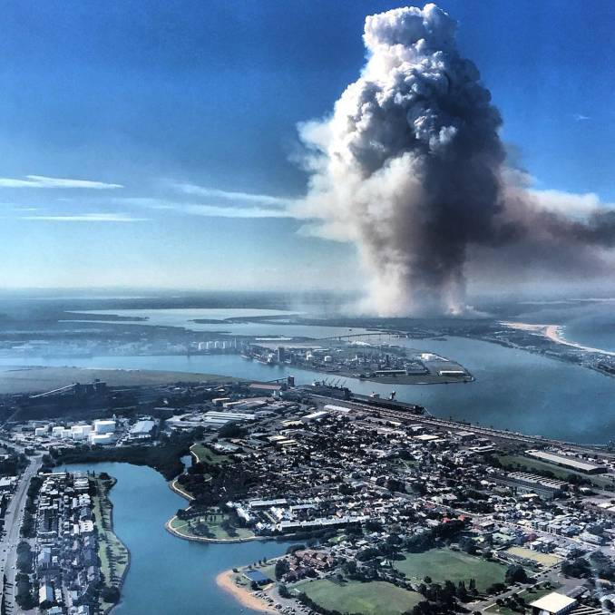
Fig 3. Prescribed burning on the area of 100 hectares in the forest of Worimi Conservation Lands, USA (Source)
The burning produces a cloud of smoke similar to the bomb explosion. The source says nothing about the causes of burning, except that it is “100-hectare hazard reduction burn”. Apparently, this is a type of burning, which is carried out for regular removal of the "fuel load" (plant litter and grass cover).

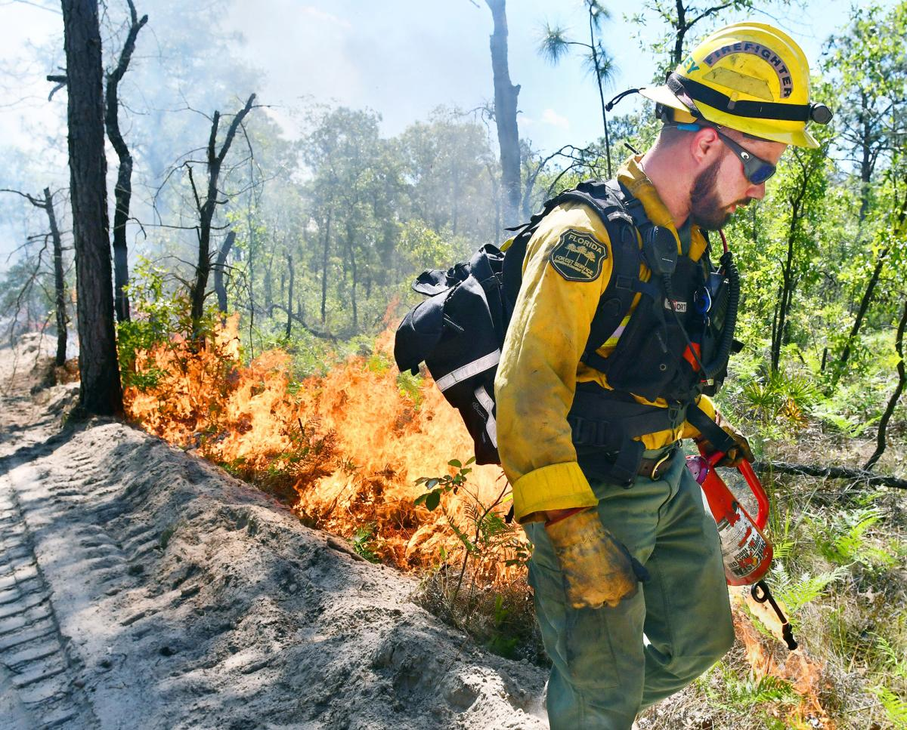
Fig 4. Prescribed burning in the forest area of Florida state, USA (Source).

It is seen that the burning goes inside the forest, covering shrubs, grass cover and plant litter. The source gives the answers about justification of prescribed burning which is very typical for the apologists of this practice. Below are the citation from the text of the article and our comments.
1. “Prescribed fires are really an economical way to manage lands….Without the flames wiping forest floors clean, not only will the wildfire threat be increased, but new grasses won’t be spurred to grow.”
According to the people who implemented the burning, how did the grass grow in this forest before the arrival of the first people with torches and matches? They do not ask themselves this question, as well as other difficult questions about the consequences of what they are doing. The main thing for them is confidence in this: “Prescribed fires are really an economic way to manage lands”.
2. “These tracts are split into sections, which forestry monitors for debris buildup or a lack of plant life for the ground-feeding quails, turkeys or tortoises to survive on. If it gets too thick or bushy ... they can’t eat, Tear said. We plan ahead of time throughout the year when managing lands to burn”.
The answer shows concern for 3 species (or 3 groups) of animals and total disregard for the impact of burning on the other plant and animal species of forest ecosystem. Unjustified confidence that without burning these three species will not be able to eat is shown.

3. “Once a prescribed or controlled burn is needed, forestry “writes a prescription” that outlines its plan for the manmade fire.”
A clear confirmation of the fact that prescribed burning is implemented very often and natural intervals of wildfires are not taken into account. The frequency of burning is determined by the officials of the forest service, based on the amount of accumulated “fuel” in ecosystem.
4. “Tear said animals living in the path of these fires are safe and know to migrate beyond the firebreak or burrow underneath, out of reach from the low-temperature burn.”
Whether the author of these words knows about existence of animals of small and tiny size in forest ecosystem for which it is unreal to escape from the burning territory even in some square meters? These are reptiles, amphibians, small mammals and birds, all invertebrates. Who should die from such burning on 100% of their quantity. Due to regular frequent burning the most of small species should have disappeared from the forest ecosystem long time ago.
5. “We appreciate everybody’s support of our program, Tear said. We just want people to understand there’s true benefit to prescribed fires”
Only a series of erroneous pseudo-scientific statements are visible in the justification of burning given in this article, not the benefits.

.

One of the objectives of the campaign is to promote the creation of this database for each country (see “The first task of the campaign” on pages 11-12).
See definition of harmful forms of prescribed burning according to the position of the campaign on page 2.
Detritophages (or detritus eaters) - animals and protest who feed on decomposing organic material (detritus). Look the full definition here: https://en.wikipedia.org/wiki/Detritivore
The full definition of harmful forms of prescribed burnings according to the position of the campaign see on pages 2.
The detailed explanation of all these problems is provided on pages 4-6.

